James F. Bennett February 26, 2021
Chief, Office of Renewable Energy Programs
Bureau of Ocean Energy Management
United States Department of the Interior
45600 Woodland Road VAM-OREP
Sterling, Virginia 20166

RE: Follow-Up to Request for Early Scoping Process.
Dear Mr. Bennett,

This letter and recommendations are on behalf of the Long Beach island (LBI) Coalition for Wind Without Impact. We represent a large number of residents, visitors and business interests deeply concerned with the impact of offshore wind turbines to the Island.

The project as currently conceived is not acceptable to us because of its dramatic visible impacts on an otherwise pristine ocean view and severe negative impacts on our economy resulting from lower property values and the diminished tourist industry, so vital to our survival. Although this letter is directed toward visual impacts and their impact on LBI, many also have expressed grave concerns regarding the environmental impacts of this project, both offshore and onshore.

As a result, many of our members and several LBI Townships requested an early scoping process under National Environmental Policy Act (NEPA) regulations to provide input to the Bureau before a proposed action is decided upon. We have not received any response, and it our understanding that the company will submit its construction and operations plan (COP) this month. Again, we request that you provide an early scoping process before the COP is approved.

We are not against offshore wind projects as part of our energy objectives if agreeable to impacted communities. However, the uniqueness of the project off LBI as currently envisioned in terms of turbine size and proximity to shore does not meet that criteria. We offer the following recommendations and alternatives for discussion in an early scoping process, and ask that they be evaluated in the COP review process. An early scoping process would allow for a discussion in more detail and a better understanding of our concerns and how they might be abated as this project is further considered.

Background
The lease for the current area off LBI was issued in 2016. It is a close-in location ranging from 10 to 23 miles out. Planning and development there is still at an early stage. All other U.S. states have projects starting out at least 19 miles. Overseas projects are placing larger turbines at least 44 miles out where they are not visible from shore.

The size of the wind turbines entering the market today is dramatically larger than anticipated when the Programmatic EIS was prepared in 2007 and even larger than anticipated as little as five years ago. The Programmatic EIS in Section 7.1.1 states that “the scope and time frame of this EIS are limited to current understanding of the technologies and possible activities that may be initiated in the foreseeable future-5-7 years (2007-2014). A 12-megawatt (MW) turbine is now two and one-half football fields high. Populating the current lease area with several hundred of those turbines would pose a greater visible impact to LBI than any other wind project to any other shore community in the U.S., and in fact the entire world.

More recent visual simulation work and significant new information by the Bureau of Ocean Energy Management (BOEM) and others regarding the negative visual impact of turbines and the detrimental effects on tourism-dependent shore economies has raised public awareness and local concern. Not to mention a world changed by the pandemic and the resultant increase in property value on LBI as people seek homes here because of its natural beauty. Applying the results of the aforementioned studies to this project indicates that the visual and socio-economic impact to LBI would be severe (Enclosure 1).

Beyond the quantifiable economic impacts, the BOEM should consider the value of an unvarnished ocean horizon that has stood for millennia and inspired millions of observers. This is not just a matter of aesthetics or personal preference, but an objective of the NEPA, “to fulfill the responsibilities of each generation as trustee of the environment for succeeding generations”. We would suggest that its destruction should not be taken lightly, particularly when better program alternatives are available.

Alternate Turbine Location

The BOEM OCS Alternative Energy Programmatic EIS states in Section 5.2.21.6 that the choice of location for an offshore wind facility is the single most important opportunity for visual impact mitigation. Alternate locations of the New Jersey lease area were not considered in the environmental assessment, which would have been the best time to do that, but it is not too late to do so here. We think it is so important as to require it be done during the COP review process, before the COP is approved.
A reasonable and attractive alternative for turbine placement exists starting just beyond the current lease area. The Hudson South call area shown below starts about 30 miles out and extends to about 57 miles. It has four times the wind energy capacity of the current lease area. The BOEM has estimated the power potential of its recommended areas in Hudson South at 7,331 MW (BOEM OCS Wind Energy Leasing in the New York Bight, New York Inter-governmental task force meeting, November 28, 2018). That can be compared to the 1,780 MW capacity stated in the NREL Technical Report, TP-5000-60403, Table ES-2, for the current lease area.
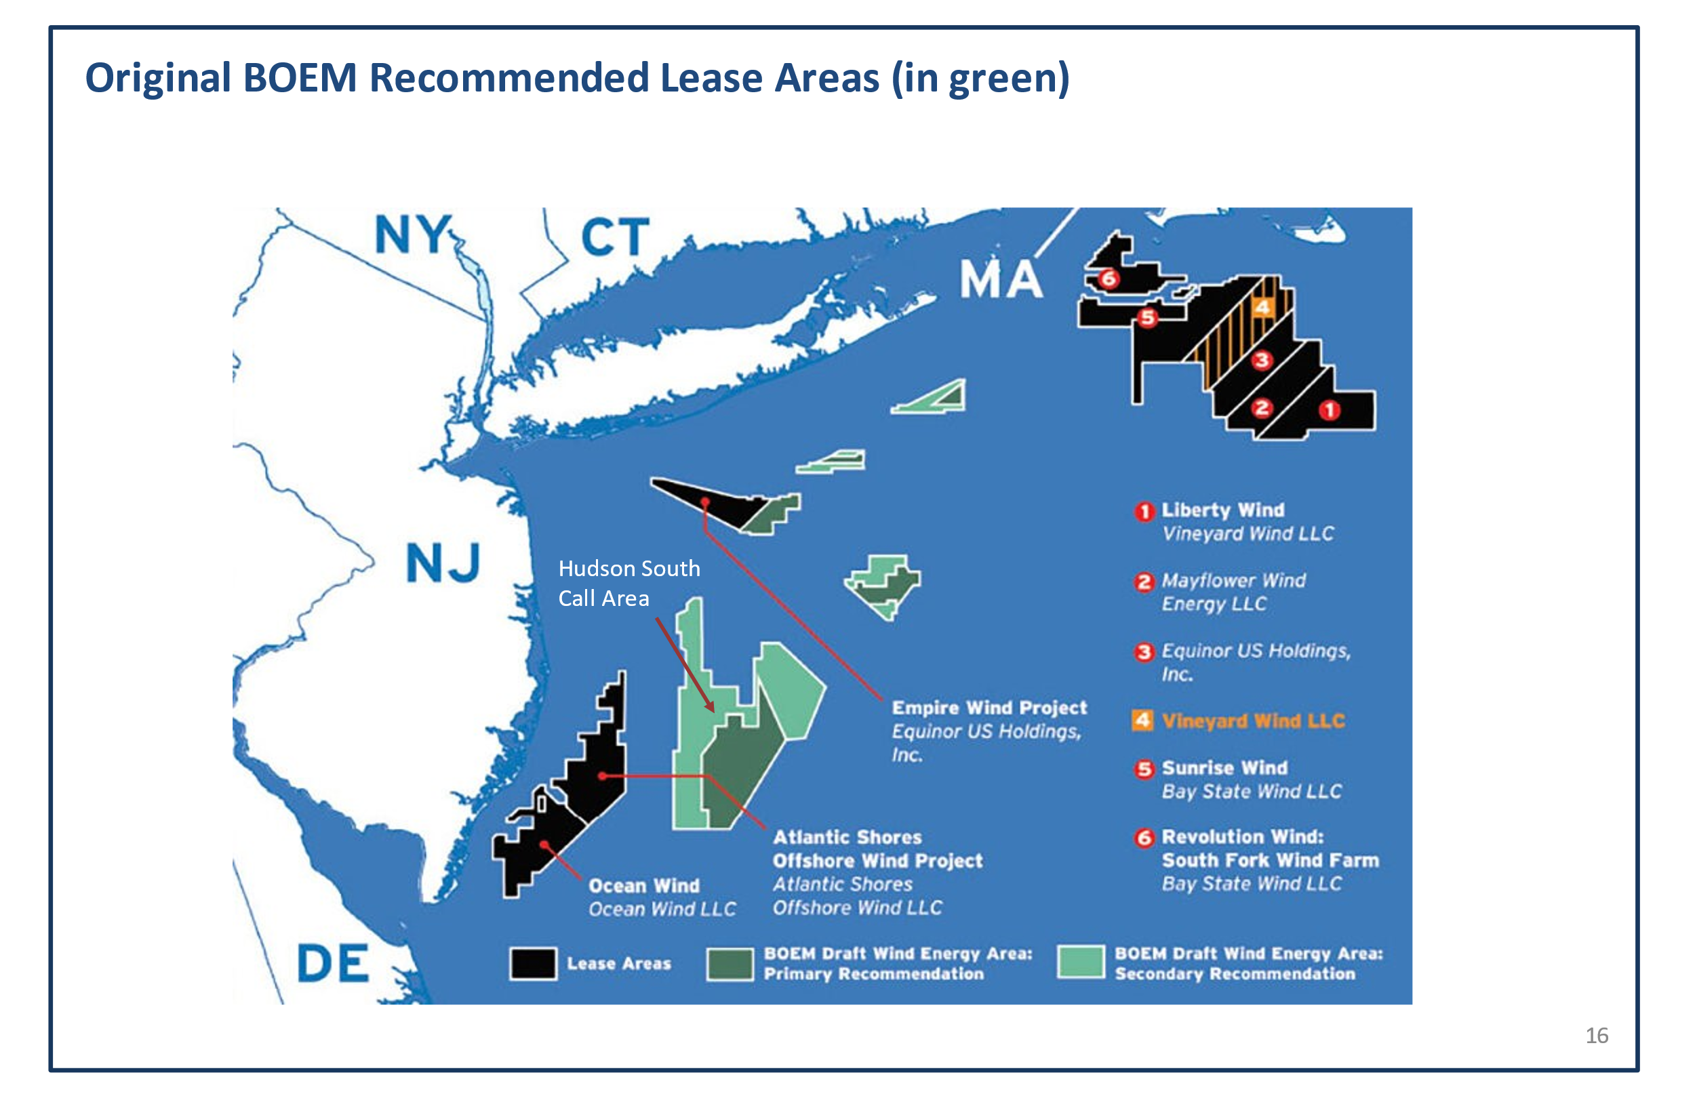
That area has already been screened by the BOEM for relevant wind project factors including visual impact, and it has been recommended for wind energy development. Water depth there is no longer a problem even for monopile foundations, and BOEM planning for it has advanced to the point where a proposed lease sale notice could be issued now.
A modest delay in wind energy development that this alternative might require is well worth preventing the irrevocable damage that the current project will cause to LBI’s economy and culture.
Therefore, since it offers advantages regarding wind turbine visibility and wind energy potential, we recommend that the Hudson South lease area be considered as the proposed project during the COP review and approval process and the current lease area be used for cable and substation transmission of all the power destined to New Jersey onshore locations from all turbines planned for the Hudson South call area. It would make good sense to have one set of transmission cables and substations rather than each company that secures a lease in the Hudson South area constructing its own, and turbine placement in the Hudson South area could eliminate the visible impact problem entirely.

In that regard, our preliminary look at turbine visibility suggests that the higher power turbines emerging today could be placed there without being visible, with the possible exception of the innermost few miles. In that section, more moderate size turbines could be used, again without being visible onshore. During the COP review process for this proposed action we ask that you provide visual renderings of proposed turbines and market available turbines at various distances in the area so we can see projected visual impacts, and have a sound basis for offering any further suggestions. Again, our request is that there be no visible impact from the shore.
A Reasonable Proposal

If the Construction and Operations Plan is anywhere near the scope described above, we would question given its detriments described above whether such a proposal is even reasonable.
On the other hand, the Hudson South turbine placement alternative presents a clear advantage, with respect to both wind energy potential and the avoidance of visible turbine impact. We also suspect, given the diligent BOEM screening of this area, that it will have other clear advantages over the current lease area as well.
Therefore, we recommend that turbine placement in the Hudson South area and substation and cable transmission through the current lease area be considered the proposed action, or at a minimum be given equal weight with the company proposal and both treated simply as options as part of the COP review process.
Alternate Power Levels

The BOEM Programmatic EIS states in section 5.22 1.4 that the visual impacts of turbine operation will be dealt with in the site-specific NEPA analysis, and lists major factors that will determine their visibility, e.g., the distance from shore, and size and number of turbines.
However, in-between the lease sale and the project draft EIS the State reaches a power purchase agreement with the applicant, and in certain project EIS’s the BOEM has used the applicant’s proposed power level as the only one assessed in the EIS.
Once the power output for the lease area is determined, given turbine powers dictated by market availability, the number of turbines is pre-determined. Turbine spacing is constrained by engineering practice and determines the minimum distance to shore. So, by the time of the draft EIS all these major factors are determined and varying them to mitigate the visible impact is foreclosed. Therefore, we recommend that the BOEM assess alternative power levels during the COP review process before a power level is approved as the proposed action. This would also facilitate and make for a more realistic process for developing the power purchase agreement.
In addition, in the purpose and need section, it would be helpful to know how that proposed power level was reached in terms of the State’s electric supply needs and what generation sources it would displace, so that the impact of the no action alternative could be better understood. Perhaps the BOEM should engage the New Jersey Board of Public Utilities as a cooperating agency in the COP review.
We hope you find these recommendations to be constructive and look forward to exploring them further with you in an early scoping process before the COP is approved. If there are any questions regarding them, please contact Bob Stern through drbob232@gmail.com or 917-952-5016.
We thank you in advance for considering these options to move forward on wind energy without unduly impacting the Island’s well-being.
Very truly yours

Robert Stern, Wendy Kouba, James Binder
On behalf of the LBI Coalition for Wind
Without Impact

Cc; Governor Phil Murphy, NJBPU, NJDEP, LBI Mayors, State representatives

Enclosure: Socio-Economic Impact

Enclosure 1, Socio-Economic Impact to LBI

The economic well-being of LBI depends on summer rentals and tourism.

A number of studies and surveys of persons shown images of turbines, including several sponsored by the BOEM have concluded that significant reductions in rental and tourism revenues, and property values will occur from visible turbines. The results of those studies are applied below to the distances and turbine sizes being considered here to evaluate the potential socio-economic impact to LBI.

New Jersey Global Insight Report, 2008

A study sponsored by the State of New Jersey and conducted by Global Insight, Inc. titled an Assessment of the Potential Costs and Benefits of Offshore Wind Turbines was conducted in 2008. It estimated the loss of tourism revenues based on the visible impact of smaller turbines place three and six miles offshore. Since the height of those turbines is 47 percent of the height of a 12-megawatt (MW) turbine the visual impact of a 12-megawatt turbine 10 miles offshore would be equivalent to the turbines used in the report sited 4.7 miles offshore. That is about halfway between their three- and six-mile scenarios.

From their data on page 43 then it can be concluded that 12 MW turbines 10 miles offshore would have resulted in $179 million of loss tourism sales for Ocean County in 2012. Scaling that up to the tourism revenue levels seen today that would mean a $280 million tourism sales loss for Ocean County, most of that to be borne by its shore communities, and much of that by LBI.

In addition, the report included estimates of oceanfront and ocean view property value losses due to visible turbines, Figures 5.3 and 5.4. Using numbers in-between the 3- and 6-mile scenarios as explained above, for Ocean County the average loss in value per property in 2012 ranges from $189,000 to $1,010,000 depending on the assumptions used. Losses would be expected to be greater today based on higher property values compared to 2012.

North Carolina State University Study, 2017

In 2017, North Carolina State University conducted a survey of persons who had previously rented oceanfront or ocean view properties. It published a report titled the Amenity Costs of Offshore Wind Farms- Evidence from a Choice Experiment in August 2017. It showed those persons visualizations of different numbers of 5 MW turbines at distances from shore of 5 to 30 miles. Since a 5 MW turbine is 60 percent of the height of the 12 MW turbines facing LBI, a 5 MW turbine at 6 miles has about the same visual impact as a 12 MW turbine at 10 miles.
It found (page 6) that 55 percent of those surveyed would not re-rent that property if turbines with visible regardless of the degree of visibility or any rental discount offered. Twenty -three percent would accept some degree visibility and twenty-one percent did not mind the visible turbines (Table 4 panel A). It also found that the negative reaction to wind turbines was primarily due to the offshore distance as opposed to the number of turbines.
Use of this lease area therefore poses an insurmountable problem for owners of ocean front and ocean view properties. To regain the 55 percent, 12 MW turbines would have to be sited much further out where the turbines would not be visible, which is not possible in this lease area.

Alternatively, they would have to in the future attract more renters who either did not mind turbine views or would accept some degree of visibility. However, the data suggests that attracting many more of the latter group would involve rental discounts that could become prohibitive.

Since the extent of the current lease area does not allow placing 12 MW turbines far enough out to not be visible, and retain many in the 55 percent group it poses a significant problem for ocean front and ocean view property owners in terms of lost rental income and property value.

BOEM/University of Delaware Study, 2018
In March,2018 the University of Delaware published a report titled Atlantic Offshore Wind Energy Development -Values and Implications for Recreation and Tourism that was sponsored by the BOEM. It assessed the impact on shore visits from visible turbines at various distances.

It interviewed 1,725 shore goers utilizing visuals of 5 MW turbines that were two-thirds the height of a 12 MW turbine. So, a 12 MW turbine at 10 miles would have about the same visual impact as data in the report for a 5 MW turbine at 6.6 miles. For that distance, it concluded (from Report Figure 3 below) that 40 percent of those surveyed will have a worse experience at the shore with turbines visible.

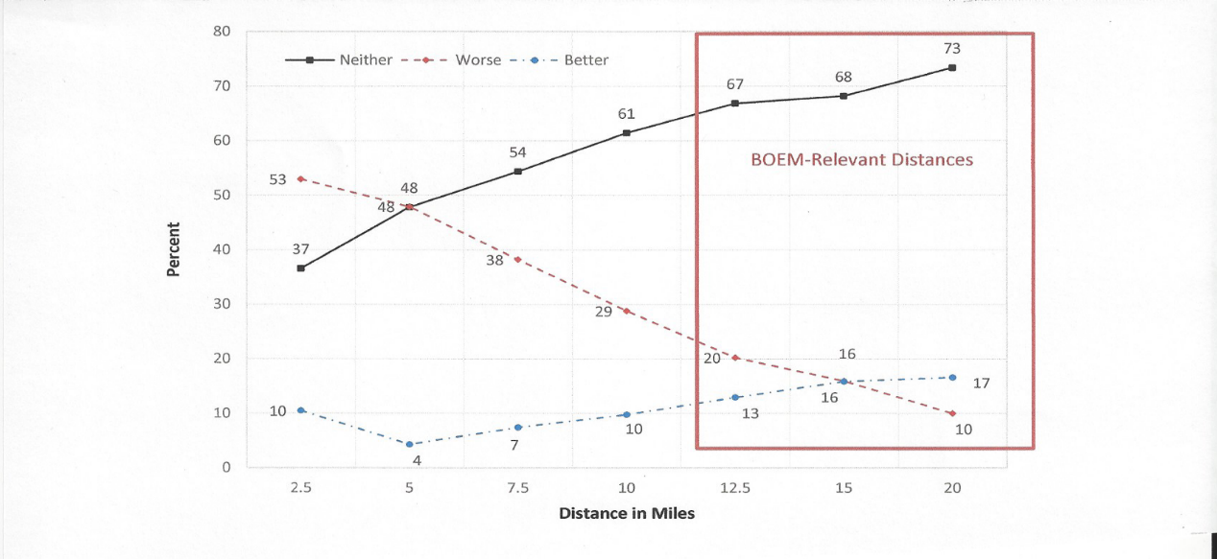

That negative reaction would result in 18 percent (from Report Figure 4 below) less visits to the shore, clearly an unacceptable impact on shore communities.

29

24
17

14
9

6

5

14

9

8

7

4
3

3
0
5
10
15
20
25
30
35
40
0
5
10
15
20
Percent

Distance in miles for 5MW Turbine
Trip Loss
Full Trip Loss (not go to another beach)
BOEM
-
Relevant Distances

To reduce that level to 6 percent, where trip loss levels off with distance, based on the data in Figure 4, would require that 12 MW turbines be placed no closer than 15/0.66 or 23 miles offshore, which is not possible in the current lease area.

BOEM Viewshed Analysis. 2015

In 2015, the BOEM published the results of a viewshed analysis it did for the New York Outer Continental Shelf Area (Renewable Energy Viewshed Analysis and Visual Simulation for the New York Outer Continental Shelf Call Area: Compendium Report OCS Study, BOEM 2015- 044).
It simulated the visual impact of one hundred and fifty-two 6.2 MW wind turbines from 16 observation points in New York and New Jersey. The simulation most relevant to LBI is the Jones Beach observation point because the turbine array was roughly parallel to that shore. The closest point of the turbine array to Jones Beach was 15 miles.
It ranked the visible impact on a scale from 1 to 6. The visual impact from Jones Beach scored a 6, its highest rating. A 6 rating was defined as; “Dominates the view because the study subject fills most of the field for views in its general direction. Strong contrast in form, line, color, texture, luminance, or motion may contribute to view dominance”.
Since the height of a 6.2 MW turbine is two-thirds that of a 12 MW, that visual impact would be equivalent to a 12 MW turbine at 23 miles. So even placing 12 MW turbines at the outer most points of the current lease area would still register a major visual impact, based on the BOEM study.

New York State Turbine Exclusion Distance, 2018

The BOEM also conducted an extensive visualization study for the Massachusetts And Rhode Island Wind Energy Areas in 2015. Based on these visualization studies and other outreach conducted by the State of New York, New York adopted a 20-mile exclusion distance for wind energy development. (FR Notice, Commercial leasing for Wind Power in the Outer Continental Shelf in the New York Area, April 18, 2018). The BOEM chose to temporarily use a 17.3-mile exclusion distance. Either way if these exclusions were applied to the New Jersey lease area they would remove most of the lease area from turbine placement.

A Local Perspective

Barnegat Lighthouse is 172 feet tall. The turbines are 5 times higher than Barnegat Lighthouse. Barnegat Lighthouse can be seen from the causeway, which is about 9 miles away. Now imagine the lighthouse 5 times taller. The turbines will be twice as tall as the Borgata (431 feet) in Atlantic City which can be seen from the causeway 25 miles to the south, and are very often visible from Holgate and Beach Haven,16 miles away.

Summary

To summarize, based on these studies this project as currently envisioned could be expected to result in:

- Several hundred million dollars in lost annual tourism revenue and
major losses in rental income and property value for oceanfront and
ocean view property owners, with implications for other property
owners (Global Insight, 2008)
- A fifty-five percent loss in prior renters of oceanfront and ocean view properties (NC State University,2017)
- Eighteen percent less Island tourist visits and forty percent of visitors having a “worse” shore experience (BOEM/University of Delaware, 2018), and
- Twelve megawatt turbines will have a dominant and disturbing visible impact even at distances further out in the lease area (BOEM Viewshed Analysis, 2015, NYS Exclusion Distance, 2018).

